Nama : Danang Aji Nugroho

NIM : L200180015

Kelas: A

**Percobaan 1**

* Buat kombinasi gerbang logiika sebagaimana pada gambar di bawah ini!

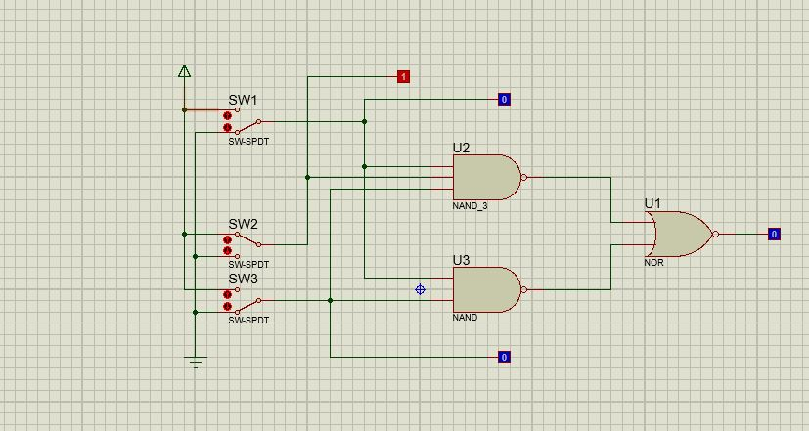

* Fungsi boolean : **F = ABC + AC**
* Isi titik-titik dalam tabel!

|  |  |  |  |
| --- | --- | --- | --- |
| **A** | **B** | **C** | **F** |
| 0 | 0 | 0 | 0 |
| 1 | 0 | 0 | 0 |
| 0 | 1 | 0 | 0 |
| 1 | 1 | 0 | 0 |
| 0 | 0 | 1 | 0 |
| 1 | 0 | 1 | 1 |
| 0 | 1 | 1 | 0 |
| 1 | 1 | 1 | 1 |

* Isi titik-titik dalam karnaugh map

AB



|  |  |  |  |  |  |
| --- | --- | --- | --- | --- | --- |
|  |  | 00 | 01 | 11 | 10 |
| C | 0 |  |  |  |  |
|  | 1 |  |  | 1 | 1 |

* Sederhanakan fungsi boolean berdasarkan karnaugh map : **F = AC**
* Gambar kombinasi gerbang logika berdasarkan fungsi boolean baru!

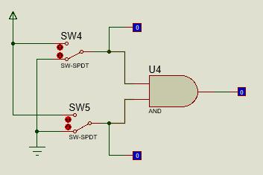

**Percobaan 2**

* Buat kombinasi gerbang logiika sebagaimana pada gambar di bawah ini!

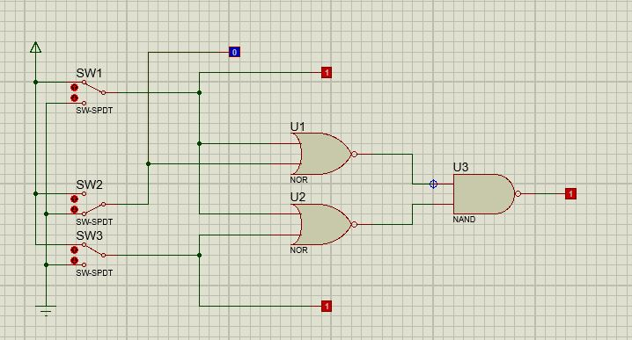

* Fungsi boolean : **F = (A + B).(A + C)**
* Isi titik-titik dalam tabel!

|  |  |  |  |
| --- | --- | --- | --- |
| **A** | **B** | **C** | **F** |
| 0 | 0 | 0 | 0 |
| 1 | 0 | 0 | 1 |
| 0 | 1 | 0 | 0 |
| 1 | 1 | 0 | 1 |
| 0 | 0 | 1 | 0 |
| 1 | 0 | 1 | 1 |
| 0 | 1 | 1 | 1 |
| 1 | 1 | 1 | 1 |

* Isi titik-titik dalam karnaugh map

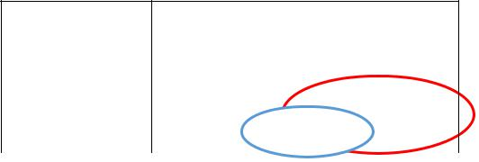AB

|  |  |  |  |  |  |
| --- | --- | --- | --- | --- | --- |
|  |  | 00 | 01 | 11 | 10 |
| C | 0 |  |  | 1 | 1 |
|  | 1 |  | 1 | 1 | 1 |

* Sederhanakan fungsi boolean berdasarkan karnaugh map : **F = A + BC**
* Gambar kombinasi gerbang logika berdasarkan fungsi boolean baru!

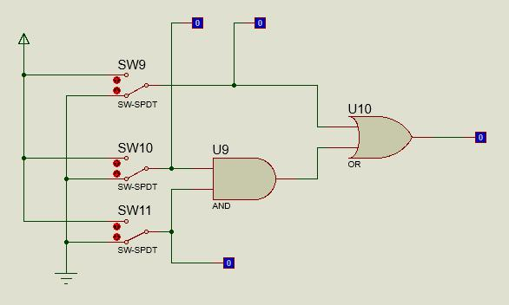

**Percobaan 3**

* Buat kombinasi gerbang logiika sebagaimana pada gambar di bawah ini!

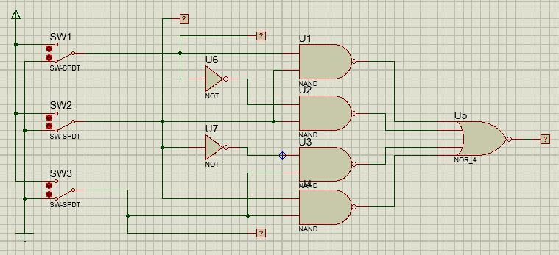

* Fungsi boolean : **F =** **AB + A’B + B’C +** **BC**
* Isi titik-titik dalam tabel!

|  |  |  |  |
| --- | --- | --- | --- |
| **A** | **B** | **C** | **F** |
| 0 | 0 | 0 | 0 |
| 1 | 0 | 0 | 0 |
| 0 | 1 | 0 | 1 |
| 1 | 1 | 0 | 1 |
| 0 | 0 | 1 | 1 |
| 1 | 0 | 1 | 1 |
| 0 | 1 | 1 | 1 |
| 1 | 1 | 1 | 1 |

* Isi titik-titik dalam karnaugh map

|  |  |  |  |  |  |  |
| --- | --- | --- | --- | --- | --- | --- |
|  |  |  |  | AB | |  |
|  |  | 00 | 01 |  | 11 | 10 |
| C | 0 |  | 1 |  | 1 |  |
|  | 1 | 1 | 1 |  | 1 | 1 |

* Sederhanakan fungsi boolean berdasarkan karnaugh map : **F = B + C**
* Gambar kombinasi gerbang logika berdasarkan fungsi boolean baru!

